Створюємо функцію для формування налаштувань модуля Vuex  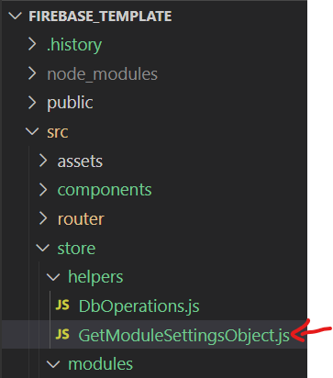 | import DbOperations from './DbOperations'  function getModuleSettingsObject(collectionTitle) {  const collectionDB = new DbOperations(collectionTitle)  return {  namespaced: true,
state: () => ({
[collectionTitle]: [],
loading: false,
error: null,
}),

getters: {
isLoading:state=>state.loading,
hasError:state=>state.error,

getItemsList: (state) => state[collectionTitle],
getItemById: (state) => (itemId) => state[collectionTitle].find((item) => item.id == itemId),
},

mutations: {
setItemsList(state, itemsList) {
state[collectionTitle] = itemsList
},
addItem(state, item) {
state[collectionTitle].push(item)
},
deleteItem(state, deleteItemId) {
state[collectionTitle] = state[collectionTitle].filter((item) => item.id !== deleteItemId)
},
setLoading(state, value) {
state.loading = value
},
setError(state, error) {
state.error = error
},
},

actions: {
loadList({ commit }) {
commit('setError', null)
commit('setLoading', true)
collectionDB
.loadItemsList()
.then((list) => {
commit('setItemsList', list)
})
.catch((error) => {
commit('setError', error)
})
.finally(() => {
commit('setLoading', false)
})
},
addItem({ commit, dispatch }, item) {
commit('setError', null)
commit('setLoading', true)
collectionDB
.addItem(item)
.then(() => {
dispatch('loadList')
})
.catch((error) => {
commit('setError', error)
})
.finally(() => {
commit('setLoading', false)
})
},
deleteItem({ commit, dispatch }, itemId) {
commit('setError', null)
commit('setLoading', true)

collectionDB
.deleteItem(itemId)
.then(() => {
dispatch('loadList')
})
.catch((error) => {
commit('setError', error)
})
.finally(() => {
commit('setLoading', false)
})
},
updateItem({ commit, dispatch }, { itemId, data }) {
commit('setError', null)
commit('setLoading', true)

collectionDB
.updateItem(itemId, data)
.then(() => {
dispatch('loadList')
})
.catch((error) => {
commit('setError', error)
})
.finally(() => {
commit('setLoading', false)
})
},
loadFilteredData({ commit }, { fieldTitle, compareOperator, valueToCompare }) {
commit('setError', null)
commit('setLoading', true)
collectionDB
.loadFilteredData(fieldTitle, compareOperator, valueToCompare)
.then((list) => {
commit('setItemsList', list)
})
.catch((error) => {
commit('setError', error)
})
.finally(() => {
commit('setLoading', false)
})
},

},

}
}

export default getModuleSettingsObject

Створюємо модуль  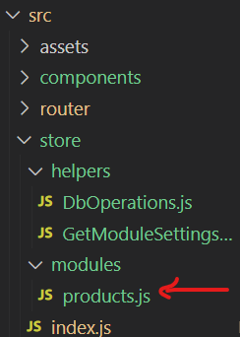 | import getModuleSettingsObject from '../helpers/GetModuleSettingsObject'  export default {  ...getModuleSettingsObject('products'),  }
Підключаємо модуль  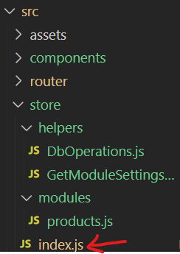 | import { createStore } from 'vuex'  import products from './modules/products'  export default createStore({  namespaced: true,  modules: {  products,  },  })
Або можна одразу створювати модулі у кореневому сховищі | import { createStore } from 'vuex'  import getModuleSettingsObject from './helpers/GetModuleSettingsObject'  export default createStore({  namespaced: true,  modules: {  products: getModuleSettingsObject('products'),  },  })

